**Experiment 3.3**

**Name :- Yash Gupta Uid :- 20BCS5009**

**Course :- CSE Section :- 709-A**

**Subject :- Programming in Python Subject Code :- 20CSP-259**

Aim :-

1. Write a Python program to generate 26 text files named A.txt, B.txt, and so on up to Z.txt
2. Write a Python program to create a file where all letters of English alphabet are listed by specified number of letters on each line
3. Write a Python program to read a random line from a file.
4. Write a Python program to count the frequency of words in a file
5. Write a Python program to copy the contents of a file to another file

Code :-

import string, os

if not os.path.exists("letters"):

os.makedirs("letters")

for letter in string.ascii_uppercase:

with open(letter + ".txt", "w") as f:

f.writelines(letter)

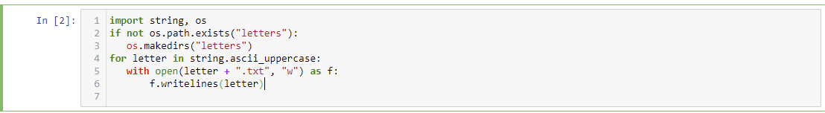

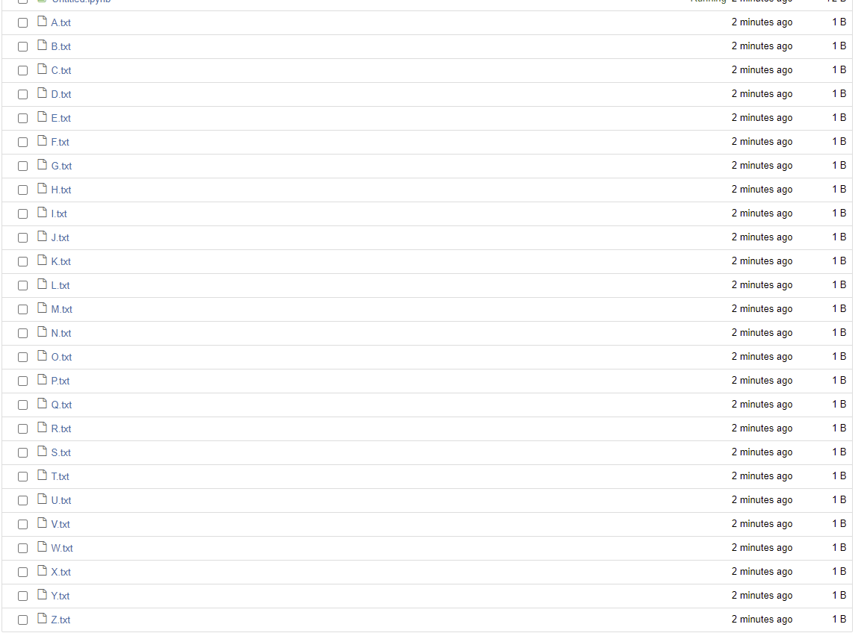

alphabet_list = list(string.ascii_uppercase)

#number of alphabets

s=6

a=0

#counting number of loops

loop=int(26/s)

if 26%s != 0:

loop += 1

#print(loop) #if 26/6 we get 4.3 so we need 5 loops

l=0

i=0

while i<=loop:

name = "".join(alphabet_list[l:l+s]) # l from 0-->s then l+s-->l+s+s ..

with open(name + ".txt", "w") as f:

f.writelines(name)

#print(i,l,l+s-1)

l+= s

i+= 1

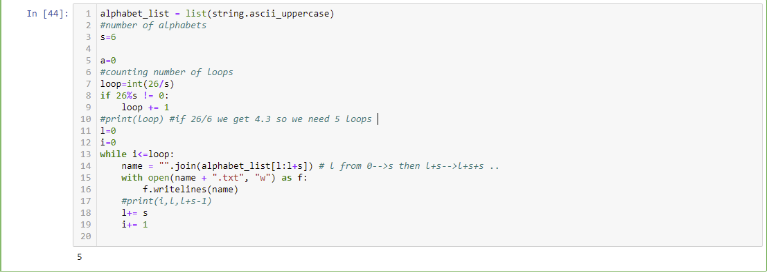

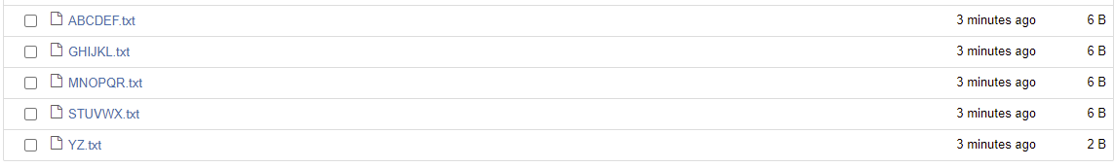

import random

def random_line(a):

lines = open(a).read().splitlines()

return random.choice(lines)

print(random_line('ABCDEF.txt'))

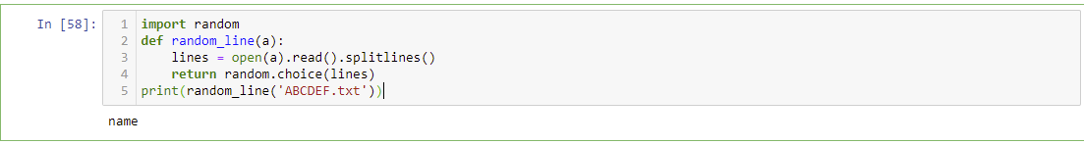

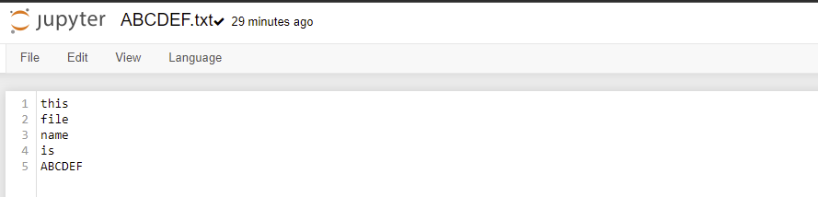

from collections import Counter

def word_count(fname):

with open(fname) as f:

return Counter(f.read().split())

print(word_count("ABCDEF.txt"))

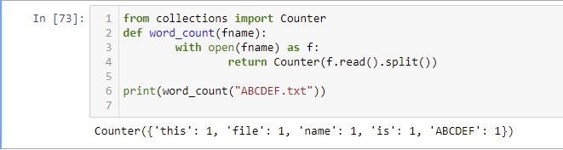

with open('ABCDEF.txt','r') as firstfile, open('GHIJKL.txt','a') as secondfile:

for line in firstfile:

secondfile.write(line)



